Lab Assignment-1
Q.1>Daxpy:
Metric | Observation | Impact on efficiency
Utilization | Increased from 0.985 to 1.45 | Increasing the threads increased the utilization.
IPC | Decreased from 1.05 to 0.55 | Degradation due to memory stalls and cache coherence overhead.
Time  Elapsed | Decreased from 0.063 to 0.04 | Speedup due to parallelization
Page Faults | Increased from 293039 to 293072 | Memory bound in nature also vector size was 50000000.

Threads (N) | Execution Time (s) | Speedup (S) | Efficiency (E=S/N) | GFlops
1 | 0.063 | 1 | 100% | 1.639
2 | 0.07 | 0.9 | 45% | 1.429
4 | 0.046 | 1.368 | 34.2% | 2.174
8 | 0.04 | 1.566 | 19.6% | 2.5
16 | 0.057 | 1.093 | 6.8% | 1.754

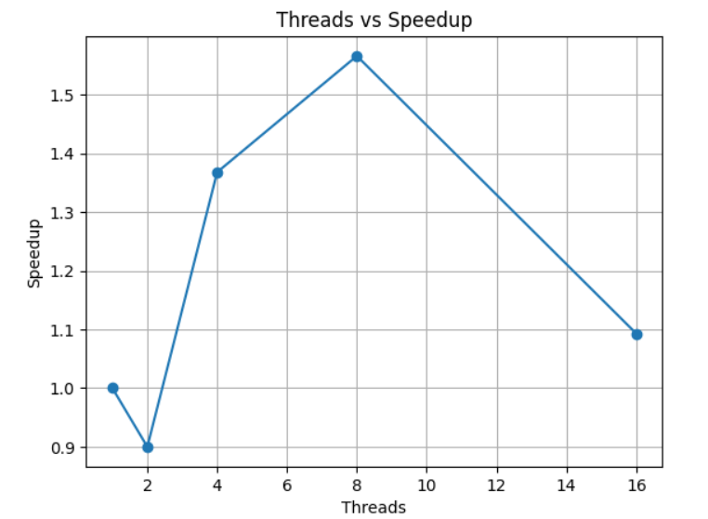
In this program, we determined the optimal number of threads that provides the maximum speedup. The best performance was obtained at around 8 threads. To obtain stable and reliable results, the DAXPY operation was executed multiple times and the execution times were averaged. This helps reduce fluctuations caused by system noise and gives a more accurate measurement.
From the speedup graph, we can see that performance increases as the number of threads increases up to the optimal point after the speedup starts decreasing. This clearly shows that increasing the number of threads does not always lead to better performance.
According to Amdahl’s Law the maximum achievable speedup of a parallel program is limited by the portion of the code that remains serial. Even if most of the program is parallelizable, a small sequential part and the parallel overhead restrict the overall improvement. Therefore, after a certain number of threads, adding more threads does not significantly reduce execution time and may even degrade performance. This is visible in our results where speedup saturates and then declines instead of scaling linearly.
The main reason for this behavior is the overhead associated with parallel execution. As more threads are created, the cost of thread management, scheduling, synchronization barriers, and OpenMP runtime handling also increases. These overheads reduce the effective computation time and limit the achievable gains.
The DAXPY kernel is memory-bound rather than compute-bound. In each iteration, there are two memory reads and one memory write, which corresponds to 24 bytes of memory traffic, while only one multiplication and one addition are performed (2 FLOPs). This gives a very low computational intensity of approximately 0.083 FLOPs per byte. Because of this, the performance is limited mainly by memory bandwidth rather than processor speed. When multiple threads execute simultaneously, they compete for the same memory bandwidth, which causes congestion and reduces the benefits of parallelism.
At higher thread counts, especially when the number of threads exceeds the number of physical cores, additional issues such as context switching and cache contention appear. Threads spend more time waiting for CPU time and memory access instead of doing useful work, which further reduces efficiency.
It was also observed that for smaller vector sizes that fit entirely inside the CPU cache, almost no speedup was achieved. In such cases, the computation is already fast, and the parallel overhead dominates. Threads spend more time synchronizing with each other rather than performing actual computation, resulting in negligible improvement.
Overall, the results show that there exists an optimal thread count for this workload. Beyond this point, the combined effects of serial portions, runtime overhead, memory bandwidth limitations, and resource contention outweigh the advantages of parallel execution, leading to reduced speedup and efficiency.

Q.2>Matrix Multiplication:
Matrix size = 1000 x 1000
Metric | Observation | Impact on efficiency
Utilization | Increased from 0.625 to 1.162 | Higher cpu util. due to parallelization reducing idle time.
IPC | Decreased from 1.74 to 1.15 | Lower IPC indicates stalls due to memory access and cache misses, reducing per-core efficiency and limiting speedup.
Time  Elapsed | Decreased from 2.394 to 0.471 in 1D and from 2.424 to 0.514 in 2D | Reduced execution time directly improves speedup and overall throughput, showing benefits of parallelization.
Page Faults | 9866 | Expected for a matrix this size.

1D Thread vs speedup
Threads (N) | Execution Time (s) | Speedup (S) | Efficiency (E=S/N) | GFlops
1 | 2.394 | 0.987 | 98.75% | 0.835
2 | 1.172 | 2.148 | 107.38% | 1.706
4 | 0.707 | 3.287 | 82.18% | 3.386
8 | 0.526 | 4.382 | 54.78% | 4.331
16 | 0.471 | 4.941 | 30.88% | 3.89

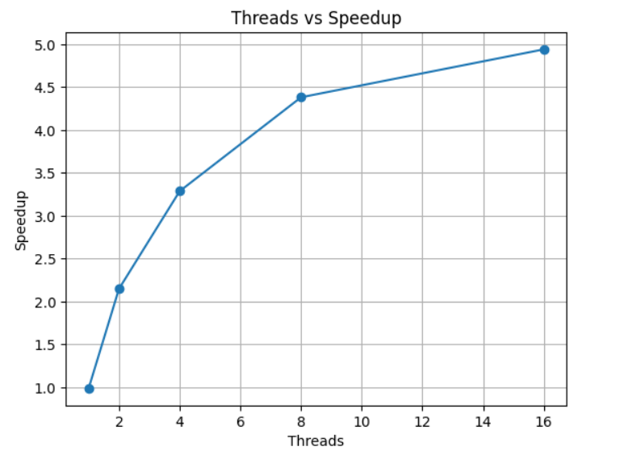

For 2D
Threads (N) | Execution Time (s) | Speedup (S) | Efficiency (E=S/N) | GFlops
1 | 2.424 | 0.975 | 97.52% | 0.825
2 | 1.267 | 1.987 | 99.33% | 1.579
4 | 0.674 | 9.448 | 86.2% | 2.967
8 | 0.557 | 4.138 | 51.73% | 3.391
16 | 0.514 | 4.527 | 28.3% | 3.89

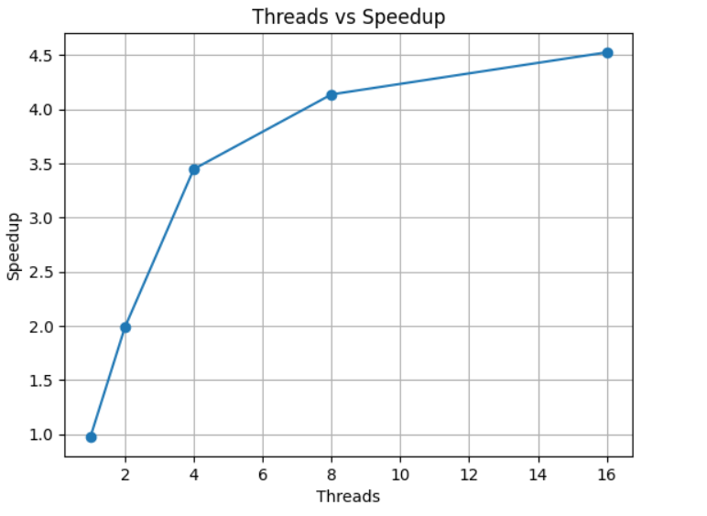
Speedup vs Threads for matrix size 2000
For 1D
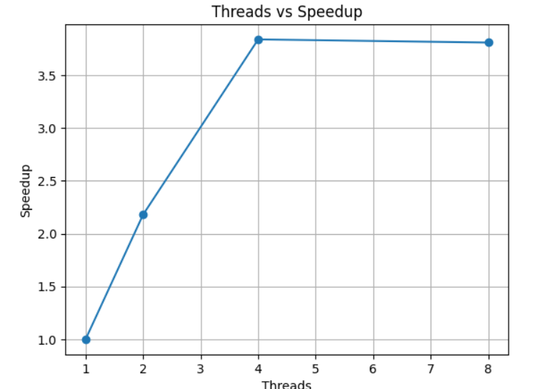

For 2D:

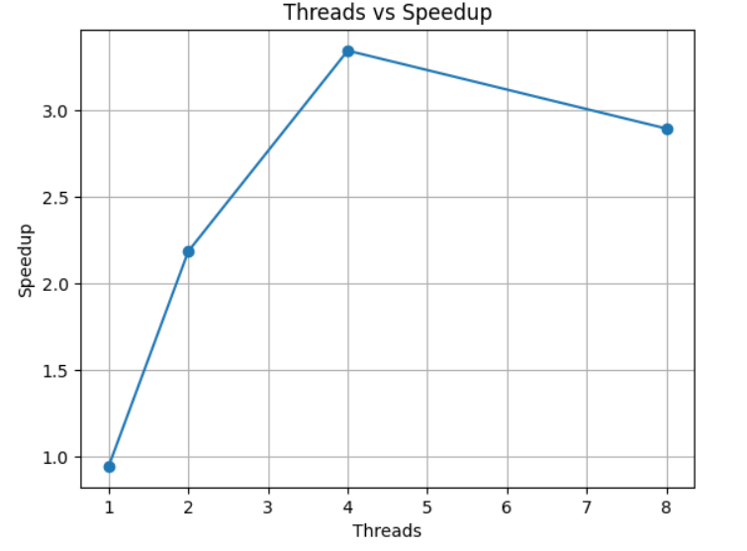
Similar trends are observed for larger matrix sizes (4000 and above). In these cases, the effect of parallelization becomes much more noticeable, with execution time reducing significantly (for example, from around 506 s to nearly 250 s). This shows that for larger workloads, the computation is heavy enough to properly utilize multiple threads and the parallel overhead becomes relatively small compared to useful work.
However, this improvement comes with certain costs. As the matrix size increases, the number of page faults rises considerably, increasing from 9866 for size 1000 to 39194 for size 2000 and further to 49890 for size 4000. This happens because larger matrices no longer fit in cache and require frequent accesses to main memory. The cache misses also increase significantly with size, which introduces memory stalls and reduces overall efficiency.
From the graphs, we can clearly observe that matrix multiplication shows better scalability compared to DAXPY. While DAXPY performance dropped after reaching the optimal number of threads due to memory bandwidth limitations, matrix multiplication continues to benefit from additional threads for a longer range. This is because matrix multiplication is highly compute-bound, performing approximately $2N^{3}$floating point operations. Since more computations are performed per memory access, the processor spends more time doing useful arithmetic rather than waiting for memory, resulting in better utilization of cores.
This behavior is also reflected in the GFLOPS metric. As the number of threads increases, GFLOPS increases initially, indicating higher computational throughput and better use of hardware resources. After a certain point, however, GFLOPS growth slows down and eventually saturates. This saturation shows that the system has reached its practical performance limit, where adding more threads no longer increases the rate of computation.
The saturation occurs due to several hardware constraints such as limited physical cores (threads exceeding available cores cause competition for execution units), memory bandwidth limitations, synchronization overhead, cache capacity limits, and thread scheduling costs. Beyond this point, threads spend more time waiting for shared resources rather than performing useful computation, which reduces scaling efficiency.This is in line with Amdhals law.
Regarding the parallelization strategy, the 2D threading approach provides finer and more granular task distribution and theoretically offers better load balancing by parallelizing the entire $N^{2}$iteration space. However, the experimental results on this system show that the 1D implementation performs similarly or sometimes better than 2D. This is mainly because 1D assigns complete rows to threads, which reduces OpenMP scheduling overhead and improves cache locality. In contrast, the 2D approach using collapse(2) introduces additional scheduling overhead and may increase cache contention when multiple threads update nearby elements of matrix C simultaneously. The benefits of the 2D approach would likely be more visible for extremely large matrices where the workload per thread is very high.
Overall, the results demonstrate that matrix multiplication scales better than memory-bound kernels like DAXPY, achieves higher GFLOPS, and benefits more from parallelization. However, due to hardware limitations and Amdahl’s Law, perfect linear scaling is not achievable, and performance eventually saturates beyond an optimal number of threads.

Q.3> Pi-estimation

Metric | Observation | Impact on efficiency
Utilization | Increased from 0.124 to 0.147 | Higher cpu util. due to parallelization reducing idle time.
IPC | Decreased from 1.72 to 1.24 | Lower IPC indicates stalls due to memory access and cache misses, reducing per-core efficiency and limiting speedup.
Time  Elapsed | Decreased from 0.115 to 0.028 | Reduced execution time directly improves speedup and overall throughput, showing benefits of parallelization.
Page Faults | 75 | Lower pagefault as this program is mostly computation.

Threads (N) | Execution Time (s) | Speedup (S) | Efficiency (E=S/N) | GFlops
1 | 0.0115 | 1.07 | 106.9% | 5.27
2 | 0.061 | 1.9 | 95.08% | 9.86
4 | 0.04 | 2.83 | 70.63% | 15
8 | 0.028 | 3.96 | 49.55% | 23.25
16 | 0.029 | 3.79 | 31.61% | 20.69

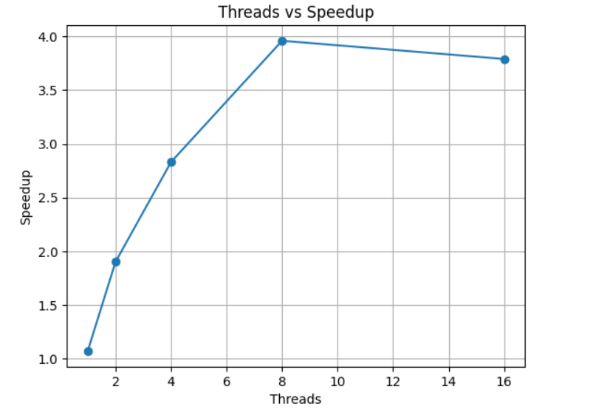

From the experimental results, it is evident that parallelizing the computation significantly improves performance up to an optimal number of threads. As the thread count increases, CPU utilization improves due to better distribution of work across cores, which reduces idle time and leads to faster execution. This is reflected in the reduced elapsed time and the steady increase in achieved GFLOPS, indicating higher computational throughput.
However, the results also show that scaling is not linear. Although execution time initially decreases with increasing threads, both efficiency and IPC begin to decline at higher thread counts. The reduction in IPC suggests increased memory stalls and cache-related delays, which limit the amount of useful work completed per cycle. Additionally, synchronization overhead and thread management costs increase as more threads are introduced, reducing the effective benefits of parallelism.
The GFLOPS trend further confirms this behavior. Throughput increases rapidly in the beginning, demonstrating good parallel scalability, but eventually saturates and slightly declines beyond the optimal configuration. This indicates that the system has reached hardware limits such as memory bandwidth, cache capacity, and available physical cores. When the number of threads exceeds the number of cores, context switching and resource contention further degrade performance.
The relatively low number of page faults shows that the workload is largely compute-bound and fits well within memory, which explains why this kernel scales better compared to memory-bound operations like DAXPY. Since more arithmetic operations are performed per memory access, the processor can utilize computational resources more efficiently, resulting in better speedup and higher GFLOPS.
These observations are also consistent with Amdahl’s Law, which states that the achievable speedup is limited by the serial portion of the program and parallel overheads. Even though most of the computation is parallelizable, factors such as synchronization, scheduling, and memory access prevent perfect linear scaling. As a result, efficiency decreases as the number of threads increases.
Overall, the experiment demonstrates that parallel execution provides substantial performance improvement up to an optimal thread count, beyond which additional threads introduce overhead and resource contention that outweigh the benefits. Therefore, selecting an appropriate number of threads is crucial for achieving maximum efficiency and performance.

